Erasmus+ programme: MEETING IN POLAND
General information:
Duration: 25th February – 1st March
Participants: The Czech Republic: 11 students+ 4 teachers
Italy: 3 students+ 4 teachers
Lithuania: 6 students+ 2 teachers
Poland: 5 students+ 4 teachers
Venue: Gimnazjum nr 6 w Poznaniu, os. Przyjazni 136*

Monday  (25.02.19) | Tuesday  (26.02.19) | Wednesday  (27.02.19) | Thursday  (28.02.19) | Friday  (01.03.19)
10.00 a.m. – 11.00 a.m.  Room: 315  Event: The official meeting of Erasmus teachers and students:  - welcome speech by our headmistress  - getting to know each other (part I),  - a short presentation – objectives and key results of the project – Lenka Novakova  - awarding the winner of the logo competition – the Czech Republic  - coffee break – getting to know each other (part II)  - a presentation of Erasmus Squad from the Czech Republic, Italy, Lithuania – pupils or teachers from other countries will introduce their local Unesco site - presentation using Power Point or Prezi ICT tools. Please all the Erasmus students be ready with the short presentation (5-10 minutes each) – part I. | 9.00 a.m. – 10.00 a.m.  Room: 315  Event:  getting to know each other, students from hosting school introduce their school and teachers, coffee time.  10.15 a.m. – 12.30 p.m.  Room: 315  Event:  - pupils from each partner school introduce their local UNESCO site – part II  - exchange of handmade Unesco sites map  - working on a map of Europe on canvas marking Unesco sites – all coordinators are in charge of helping students  - introducing the idea of Pilgrim Diary – the Czech Republic | 9.00 a.m. – 12.30 p.m.  Room: 315  Event:  “Having fun with UNESCO” – lots of games and activities for students and teachers – exchanging good practice | 9.00 a. m. – 12.30 p.m.  Room: 201  Event:  - Making a video report/presentation from excursion to Porta Posnania Ichot – Heritage Interpretation Centre – Lenka Novakova+ all teachers (part I)  - Coordinator’s meeting | 9.00 a.m. – 11.30 p.m.  Room: 315  Event:  Making a video report/presentation from excursion to Porta Posnania Ichot – Heritage Interpretation Centre – Lenka Novakova+ all teachers (part II)
12.45 p.m. – 2.30 p.m. –  Lunch time  Where: “Wysmakowani” Here you can check it out: https://tiny.pl/tx68w | 12.45 p.m. – 2.30 p.m.  Lunch time  Where: “Wysmakowani” Here you can check it out: https://tiny.pl/tx68w | 12.45 a.m.– 2.30 p.m.  Lunch time  Where: “Wysmakowani” Here you can check it out: https://tiny.pl/tx68w | 12.45 p. m. – 2.30 p.m.  Lunch time  Where: “Wysmakowani” Here you can check it out: https://tiny.pl/tx68w | 12.45 p. m. – 2.30 p.m.  Lunch time  Where: “Wysmakowani” Here you can check it out: https://tiny.pl/tx68w
5.00 p.m. – A formal dinner**  How to get there: https://brovaria.pl/contact | 4.00 p.m.- Poznan Croissant Museum and Experience. For more info: http://rogalowemuzeum.pl/en/ | 4.00 p.m.  Porta Posnania Ichot – visiting Heritage Interpretation Centre  More info: http://bramapoznania.pl/en/ | 3.00 p.m. – 5.00 a.m. – Nordic walking – visiting Park Cytadela  More info: https://en.wikipedia.org/wiki/Park_Cytadela | 2 p.m.  Explore Poznan with your Erasmus friends and teachers – free time to go sightseeing and explore Poznan!

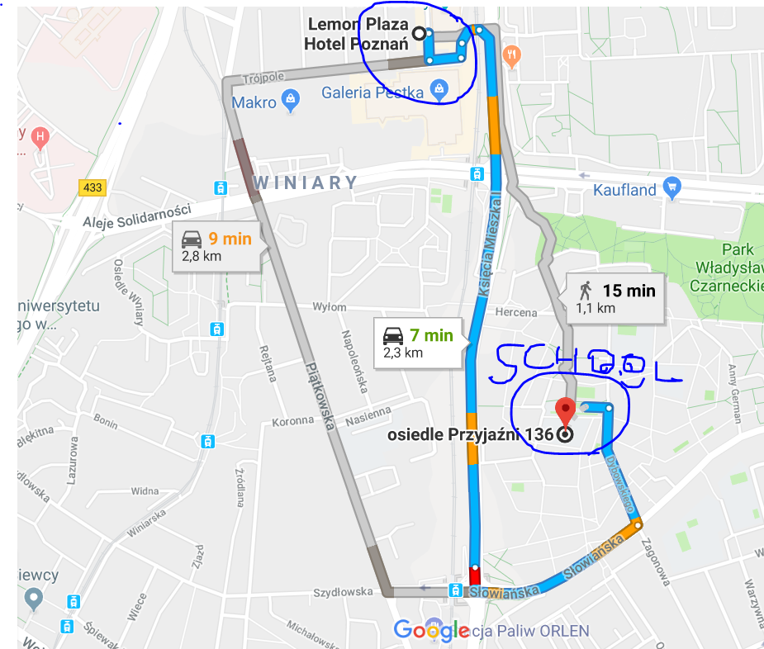
*How to get from your hotel to our school
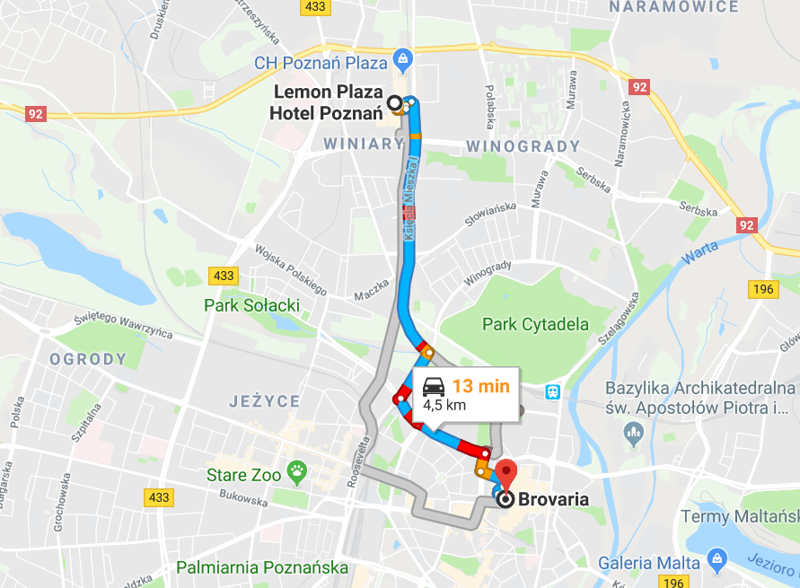
**How to get to Brovaria

