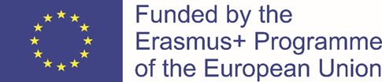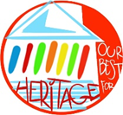
"The European Commission support for the production of this publication does not constitute an endorsement of the contents which reflects the views only of the authors, and the Commission cannot be held responsi¬ble for any use which may be made of the information contained therein."
--------------------------------------------------------------------------------------------------------------------------------------------------------------------------------------------------------------

1)Choose true statements about UNESCO, cut them out and stick on a poster:

The full name of UNESCO is The United Nations
Educational, Scientific and Cultural Organization

The full name of UNESCO is The United International
Environmental, Scientific and Cultural Organization

The UNESCO was founded in 1946.

The UNESCO was founded in 1996.

UNESCO takes care of children.

UNESCO takes care of heritage.

UNESCO takes care of only European heritage.
UNESCO takes care of the world´s heritage.

UNESCO takes care of cultural heritage only.

UNESCO takes care of cultural and natural heritage.

There aren´t any UNESCO sites in the Czech Republic.

There are some UNESCO sites in the Czech Republic.

Our capital city, Prague, is the UNESCO site.

Our capital city, Prague, isn´t the UNESCO site.

2) Find all UNESCO sites in th Czech Republic:
1. The number of Unesco sites in the C.R.:

2.
The UNESCO´s site´s name: Where is it? What is it?

3) Where can you find these UNESCO sites?
- Ankor Wat
- Kronborg castle
- Papal palace in Avignon
- Newgrange (Brú na Bóinne)
- Taj Mahal
- Masada
- Mount Etna
- Archeogical area of Agrigento
- Cuzco
- Krakow

