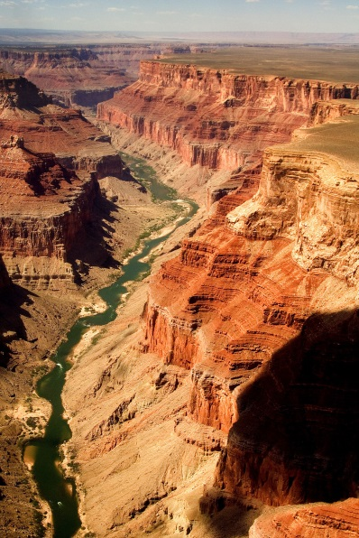  Grand canon | 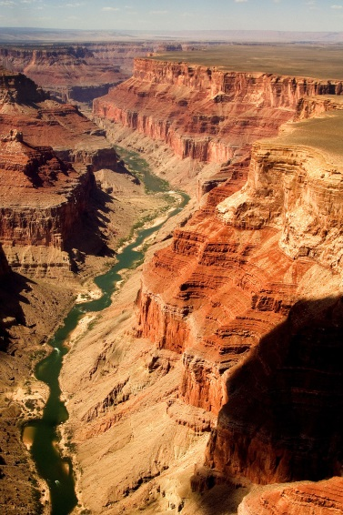  Grand canon
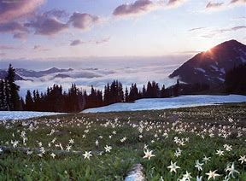  Olympic National Park | Olympic National Park
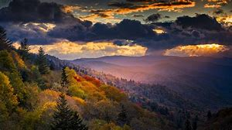  Great Smoky Mountains National Park | Great Smoky Mountains National Park

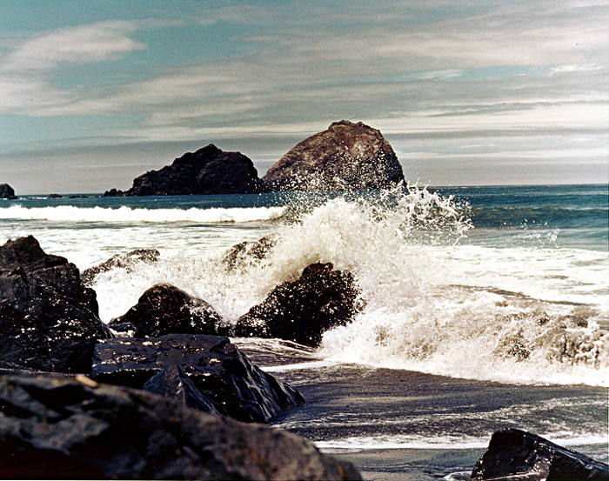  Redwood National and State Parks | Redwood National and State Parks
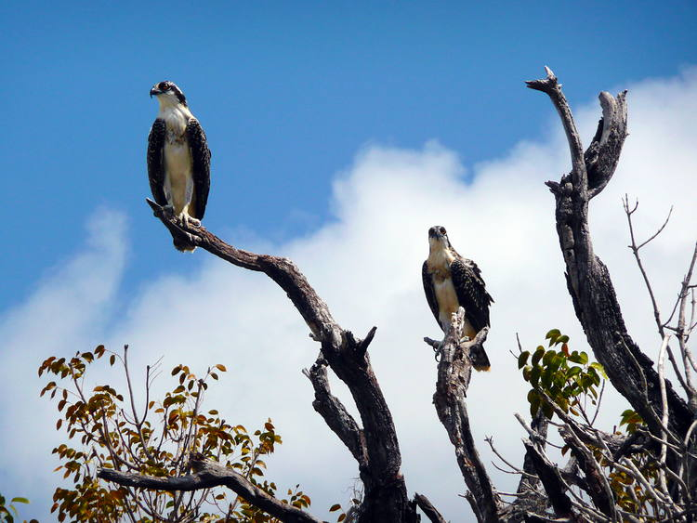  Everglades National Park | Everglades National Park
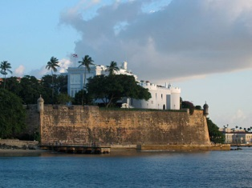  La Fortaleza and San Juan National Historic Site in Puerto Rico | La Fortaleza and San Juan National Historic Site in Puerto Rico

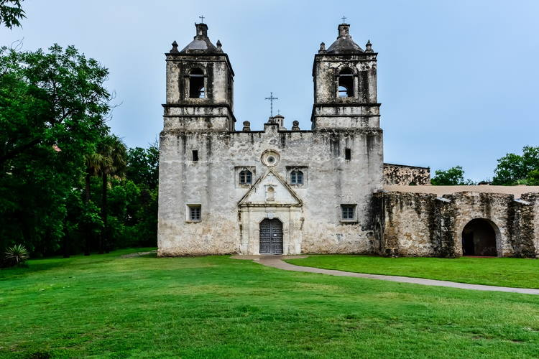  San Antonio Missions | San Antonio Missions
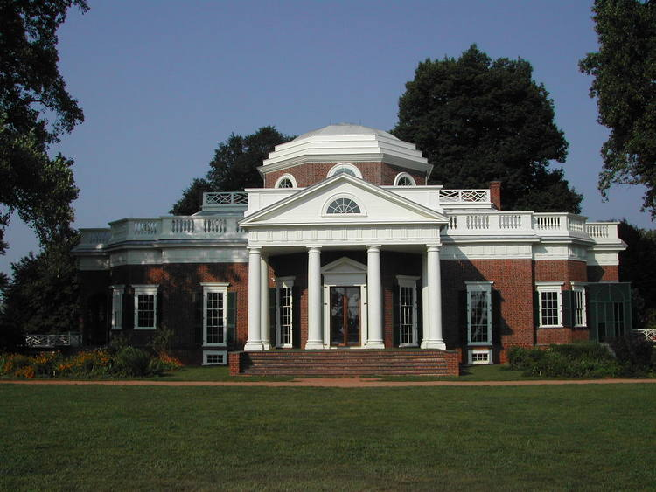  Monticello and the University of Virginia in Charlottesville | Monticello and the University of Virginia in Charlottesville
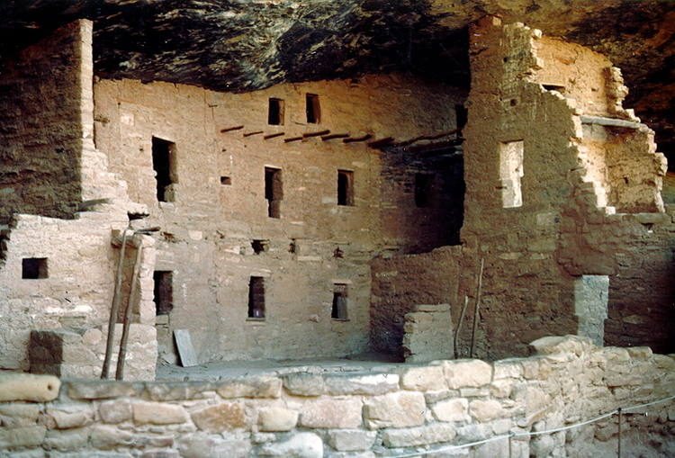  Mesa Verde National Park | Mesa Verde National Park

Statue of Liberty  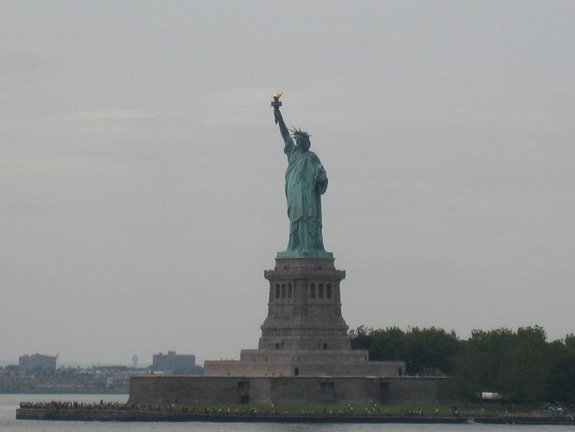 | Statue of Liberty

