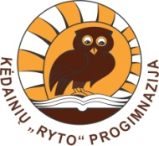
The Old Town of Vilnius
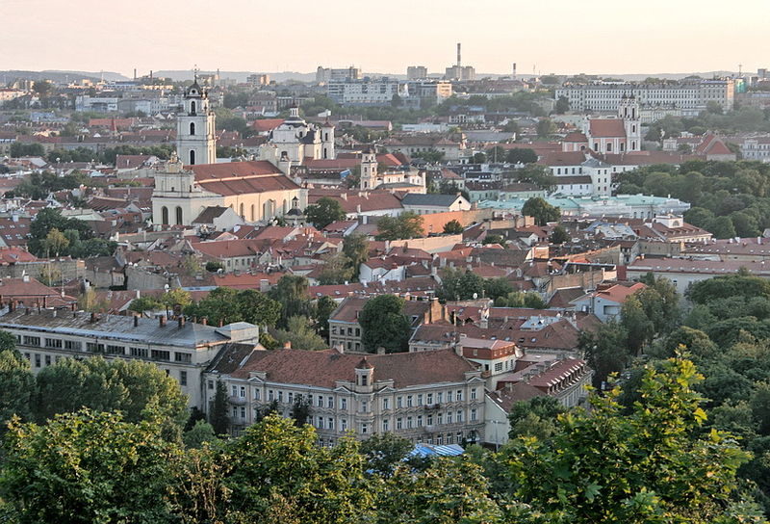
Vilnius is the capital city of Lithuania. The Old Town of Vilnius is one of the largest surviving medieval old towns in Northern Europe. It has an area of 3.59 square kilometres.
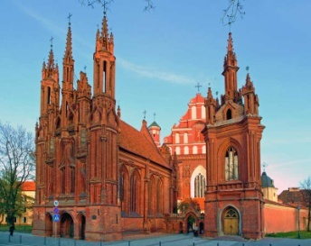
In 1994, the Old Town of Vilnius was included in the UNESCO World Heritage List in recognition of its universal value and originality.
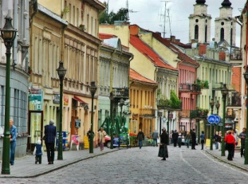
The Old Town of Vilnius encompasses 74 quarters with 70 streets and lanes numbering 1487 buildings. Visitors can find some of the Europe’s greatest architectural styles like gothic, renaissance, baroque and neoclassical standing side by side and complementing each other here.

Pilies Street is the main Old Town’s street full of cafes and where visitors can enjoy street market life.
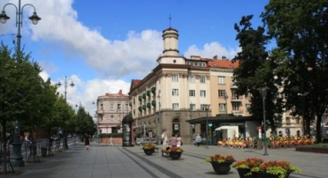
The main street of Vilnius, Gediminas Avenue, is partially located in the Old Town.

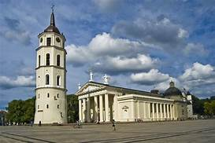
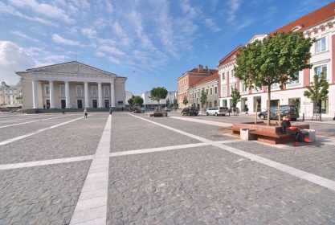
The two main squares are the Cathedral Square and the Town Hall Square.

One of the most elaborate architectural complexes is Vilnius University, founded in 1579, and which occupies a large part of the Old Town. It has even 13 courtyards. VU is the oldest university in the Baltic states and one of the oldest in Northern Europe. Moreover, it is the largest university in Lithuania.
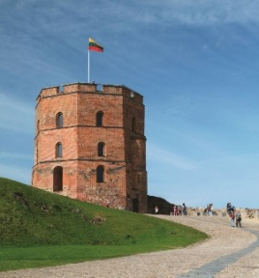
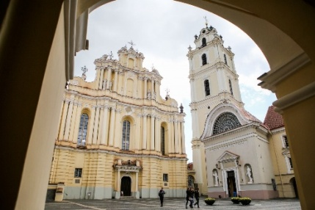
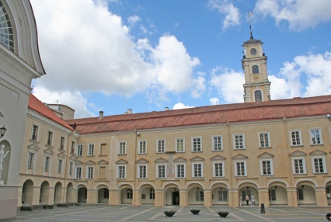
The most iconic building in the Old Town is Gediminas‘ tower, the remaining part of the Upper Castle in Vilnius. It is an important state and historic symbol of the city of Vilnius and of Lithuania itself.

The Old Town of Vilnius is full of other monuments of interests that are worth seeing and visiting. They include churches, palaces, museums and art galleries or theatres.

